Kolkata Weather Analytics Report

Table of Contents  
1. Overview  
2. Dataset Used  
3. Tools Used  
4. Data Preparation and Cleaning  
5. Analysis and Visual Insights  
6. Summary and Key Insights  
7. Conclusion

# Overview

This project aims to analyze and visualize the historical and forecasted weather trends in Kolkata, India. With rising concerns about climate variability, this dashboard offers a comprehensive overview of temperature, rainfall, humidity, and perceived temperature (heat index) data to derive insights into seasonal and yearly trends. A forecast for 2025 based on historical patterns has also been incorporated to understand future shifts.

# Dataset Used

The dataset includes daily weather data for Kolkata spanning from 2020 to 2025 (Until 21 July 2025) , including various parameters relating to the climatic conditions of Kolkata.

This data has been derived from the API of Visual Crossing website (Link to the website : <https://www.visualcrossing.com/> )

The forecast data for 2025 was generated using historical temperature patterns.

# Tools Used

* Tableau: For data visualization and dashboard creation
* Google Sheets: For initial data preparation and validation
* Python : Used to extract data from APIs and perform data cleaning and preprocessing.
* SQL : Utilized for aggregating weather metrics like averages, minimums, and maximums for different time periods.
* Facebook Prophet: Employed to forecast temperature trends for the remaining months of 2025.

# Data Preparation and Cleaning

The raw dataset underwent preprocessing steps including:  
- Standardization of date formats  
- Handling missing or null values  
- Ensuring unit consistency (e.g., °C, mm)  
- Generating calculated fields like 'Feels Gap' (difference between actual and feels-like temperature)  
- Creating a continuous timeline to integrate forecasted data seamlessly

# Analysis and Visual Insights

1. Yearly Temperature Trends

This bar chart displays the yearly average temperature trends in Kolkata from 2020 to 2024, revealing several important patterns and insights.

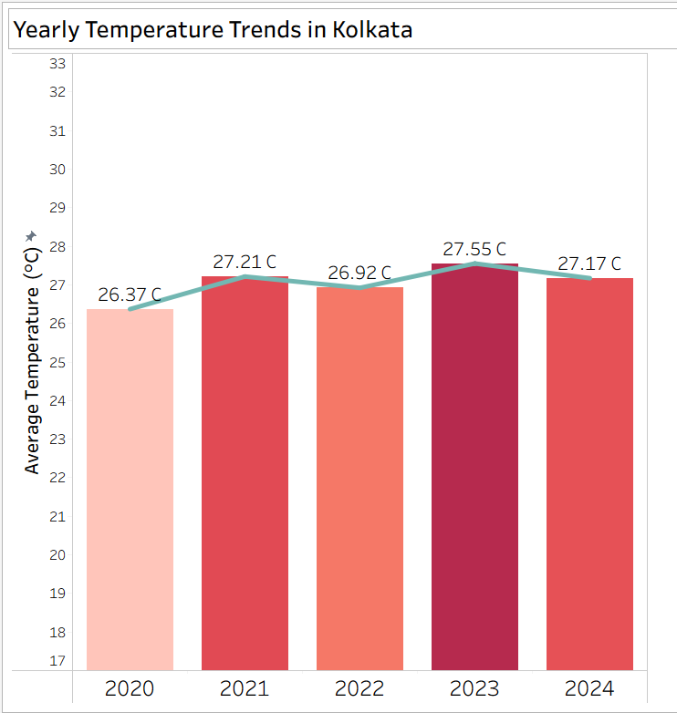

This visualization highlights Kolkata’s average annual temperatures over five years, ranging from 26.37 °C in 2020 to a peak of 27.55 °C in 2023. The year 2023 shows a significant spike, suggesting possible extreme weather or urban heat effects. Despite minor fluctuations, there’s a clear warming trend compared to 2020.

Key Insights:

* Warming Pattern: All years after 2020 recorded higher average temperatures.
* 2023 Peak: The warmest year, possibly linked to heatwaves or climate shifts.
* Temperature Increase: 1.18 °C over five years
* Implications: Temperature variability can affect monsoons, energy demand, and public health.

2. Monthly Temperature Trends

This line chart shows Kolkata's average monthly temperature pattern throughout the year, displaying a clear seasonal cycle.

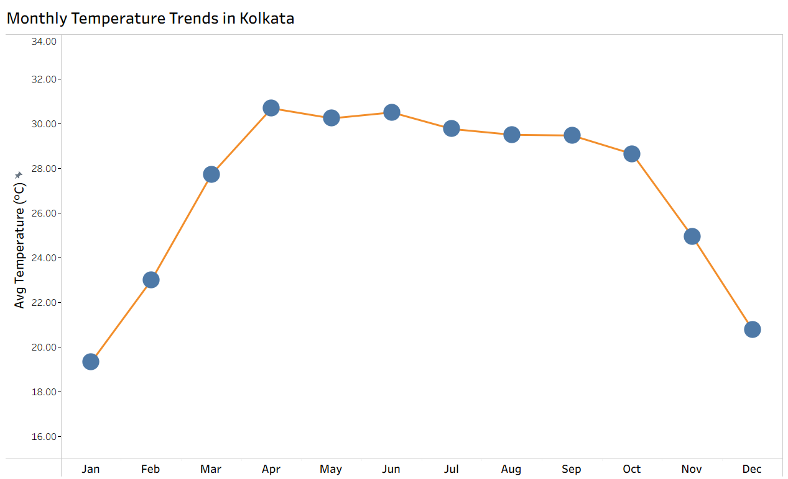

Key Insights:

* Follows a classic tropical cycle—sharp warming from winter to pre-monsoon, gradual cooling post-monsoon
* Winter Lows: January (~19.5 °C) and December (~21 °C)
* Su mmer Highs: April–June (~30–31 °C), with April as the hottest
* Monsoon Cooling: Noticeable decline from July onward due to increased rainfall
* Seasonal Range: ~11 °C between coldest and hottest months
* Use Cases : This trend supports planning across tourism, energy demand (especially su mmer cooling), agriculture, and public health preparedness.

3. Rainfall Distribution

This heatmap shows Kolkata's monthly rainfall distribution from 2020-2024, revealing clear seasonal patterns and yearly variations.

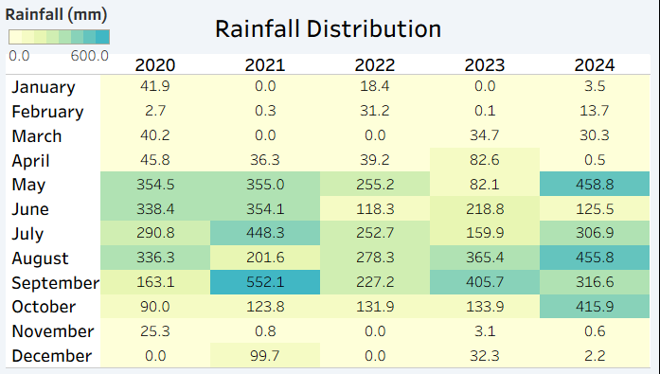

Key Insights:

* Monsoon Dominance: Heavy rainfall from May to September
* Dry Winters: Sparse rainfall from November to February
* High Yearly Variability: Notable shifts in intensity across years
* Consistent monsoon timing, with August–September being the wettest
* 2024 anomaly: Exceptionally high rainfall in May (458.8 mm) and August (455.8 mm)
* Use Case : Vital for flood control, water management, agriculture, and urban infrastructure planning, reflecting Kolkata’s dual vulnerability to droughts and flooding.

4. Feels-Like vs. Humidity

This scatter plot reveals the relationship between humidity levels and the gap between perceived temperature ("feels like") and actual temperature in Kolkata throughout the year.

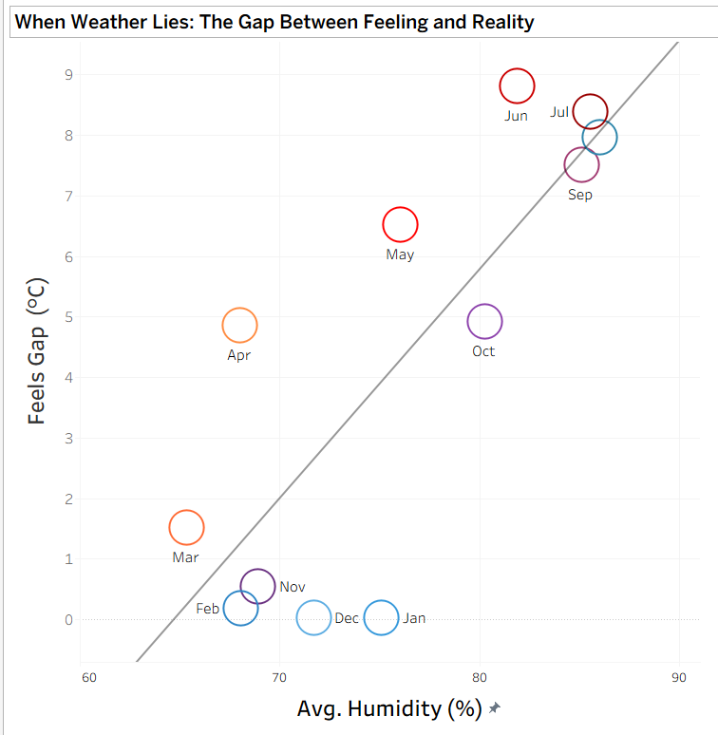

The "Feels Gap" represents the difference between the Heat Index (apparent/perceived temperature) and the actual air temperature, measured in degrees Celsius.

Key Insights:

* Diagonal trend: Clear positive correlation - higher humidity creates larger gaps between feeling and reality
* Su mmer extremes: May-July show the largest perception gaps, with June reaching nearly 9 °C difference
* Monsoon effect: Aug-Sep have high humidity but moderate feels-like gaps due to cooler actual temperatures
* Heat index impact: High humidity makes temperatures feel significantly hotter than they actually are
* Threshold effect: Once humidity exceeds ~75%, the feels-like temperature becomes dramatically higher than actual temperature
* Most deceptive months: June (82% humidity, 9 °C gap) and July (85% humidity, 8.5 °C gap) create the most uncomfortable conditions

The data shows why Kolkata's su mmers feel unbearably hot despite temperatures being lower than arid regions - the humidity factor creates dangerous heat stress conditions that require different mitigation strategies than dry heat.

5. 2025 Forecast

This chart shows Kolkata's 2025 temperature progression, combining actual recorded data (blue) with forecasted temperatures (yellow) for the remaining year.

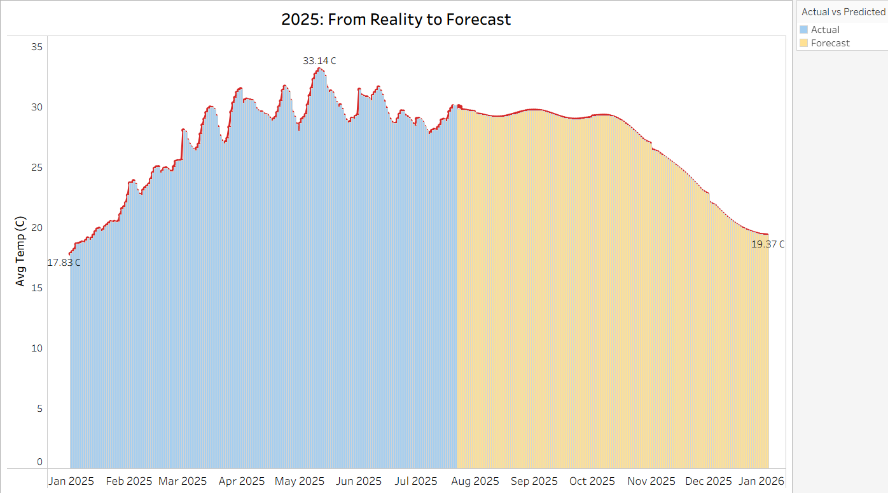

Key Insights:

* Summer peak: May reached the highest recorded temperature at 33.14 °C
* Transition point: Around July, actual data transitions to forecast predictions
* Predicted cooling: Forecast shows gradual decline to 19.37 °C by year-end
* Forecast reliability: Predicted temperatures show realistic seasonal decline through monsoon and post-monsoon periods
* Temperature range: 2025 shows ~15 °C annual variation from coolest to hottest periods
* Monsoon impact: Forecast correctly predicts temperature moderation during July-September

The combination of actual and predicted data helps validate forecasting models while providing actionable temperature expectations for the remainder of 2025.

6. Kolkata Weather Analytics Dashboard :

This comprehensive dashboard presents Kolkata's weather analytics through multiple interconnected visualizations with interactive filtering capabilities.

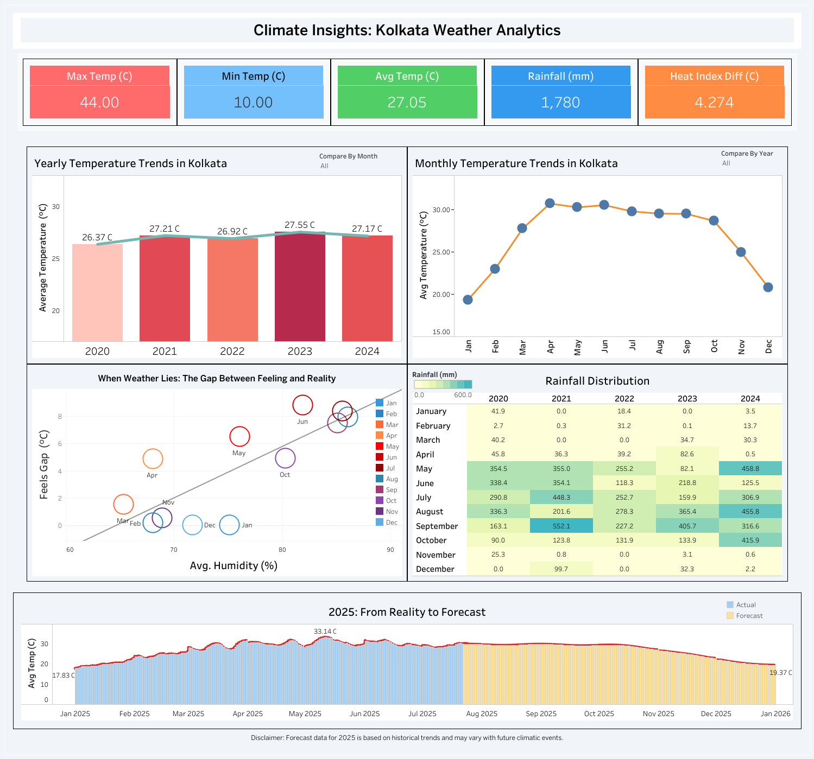

Dashboard Features and Summary:

* Temperature extremes: 10 °C to 44 °C range with 27.05 °C average
* Annual rainfall: 1,780 mm total
* Heat stress: 4.274 °C average gap between perceived and actual temperature
* Interactive Features: Month/Year comparison toggles and "All" filter options with coordinated multi-chart filtering
* Visualization Suite : Bar charts (yearly trends), line graphs (seasonal patterns/forecasts), scatter plot (humidity-heat correlation), heatmap (rainfall matrix)

This integrated dashboard supports climate adaptation planning, public health monitoring, agricultural scheduling, and energy demand forecasting. The interactive nature allows users to drill down into specific time periods or cross-reference multiple weather parameters for comprehensive analysis.

# Su mmary and Key Insights

- Average temperature has remained consistent with slight increases in recent years  
- 2023 saw an unusually high rainfall spike in select months  
- Feels-like temperatures in humid months (May–July) often exceed actual temperatures  
- Forecast shows declining temperatures toward the end of 2025  
- Su mmer months exhibit the largest gap between real and perceived heat

# Conclusion

This comprehensive analysis of Kolkata's weather patterns from 2020-2025 reveals critical climate insights that have significant implications for urban planning and public health management.

Key Findings:

The data demonstrates Kolkata's climate vulnerability through multiple dimensions. Temperature analysis shows concerning warming trends, with 2023 recording the highest average temperature (27.55 °C) and a notable 1.18 °C variation across the study period. The city experiences extreme seasonal temperature swings from 19.5 °C in winter to over 44 °C in su mmer, with April-June representing the most challenging period for human comfort and health.

Rainfall patterns exhibit high volatility, ranging from drought-like conditions in 2021 and 2023 to extreme precipitation events in 2024 (458.8 mm in May alone). This variability poses dual risks of water scarcity and urban flooding, requiring adaptive infrastructure planning.

The heat index analysis reveals a critical public health concern: high humidity levels create dangerous perceived temperatures that can exceed actual readings by up to 9 °C during su mmer months. This "feels gap" phenomenon makes Kolkata's su mmers particularly hazardous, with June and July showing the most severe heat stress conditions.

Implications:

These findings underscore the urgent need for climate-resilient urban planning, enhanced heat warning systems, improved drainage infrastructure, and adaptive public health strategies. The city's subtropical climate patterns, while predictable seasonally, show increasing extremes that demand proactive mitigation measures.

The integrated dashboard approach demonstrates how multi-parameter weather analysis can inform evidence-based policy decisions for sustainable urban development in tropical megacities facing climate change challenges.